http://www.jahonnews.uz/rus/rubriki/ekologiya/nasha_sootechestvennia_obladatelnia_premii_energy_globe_award444.mgr
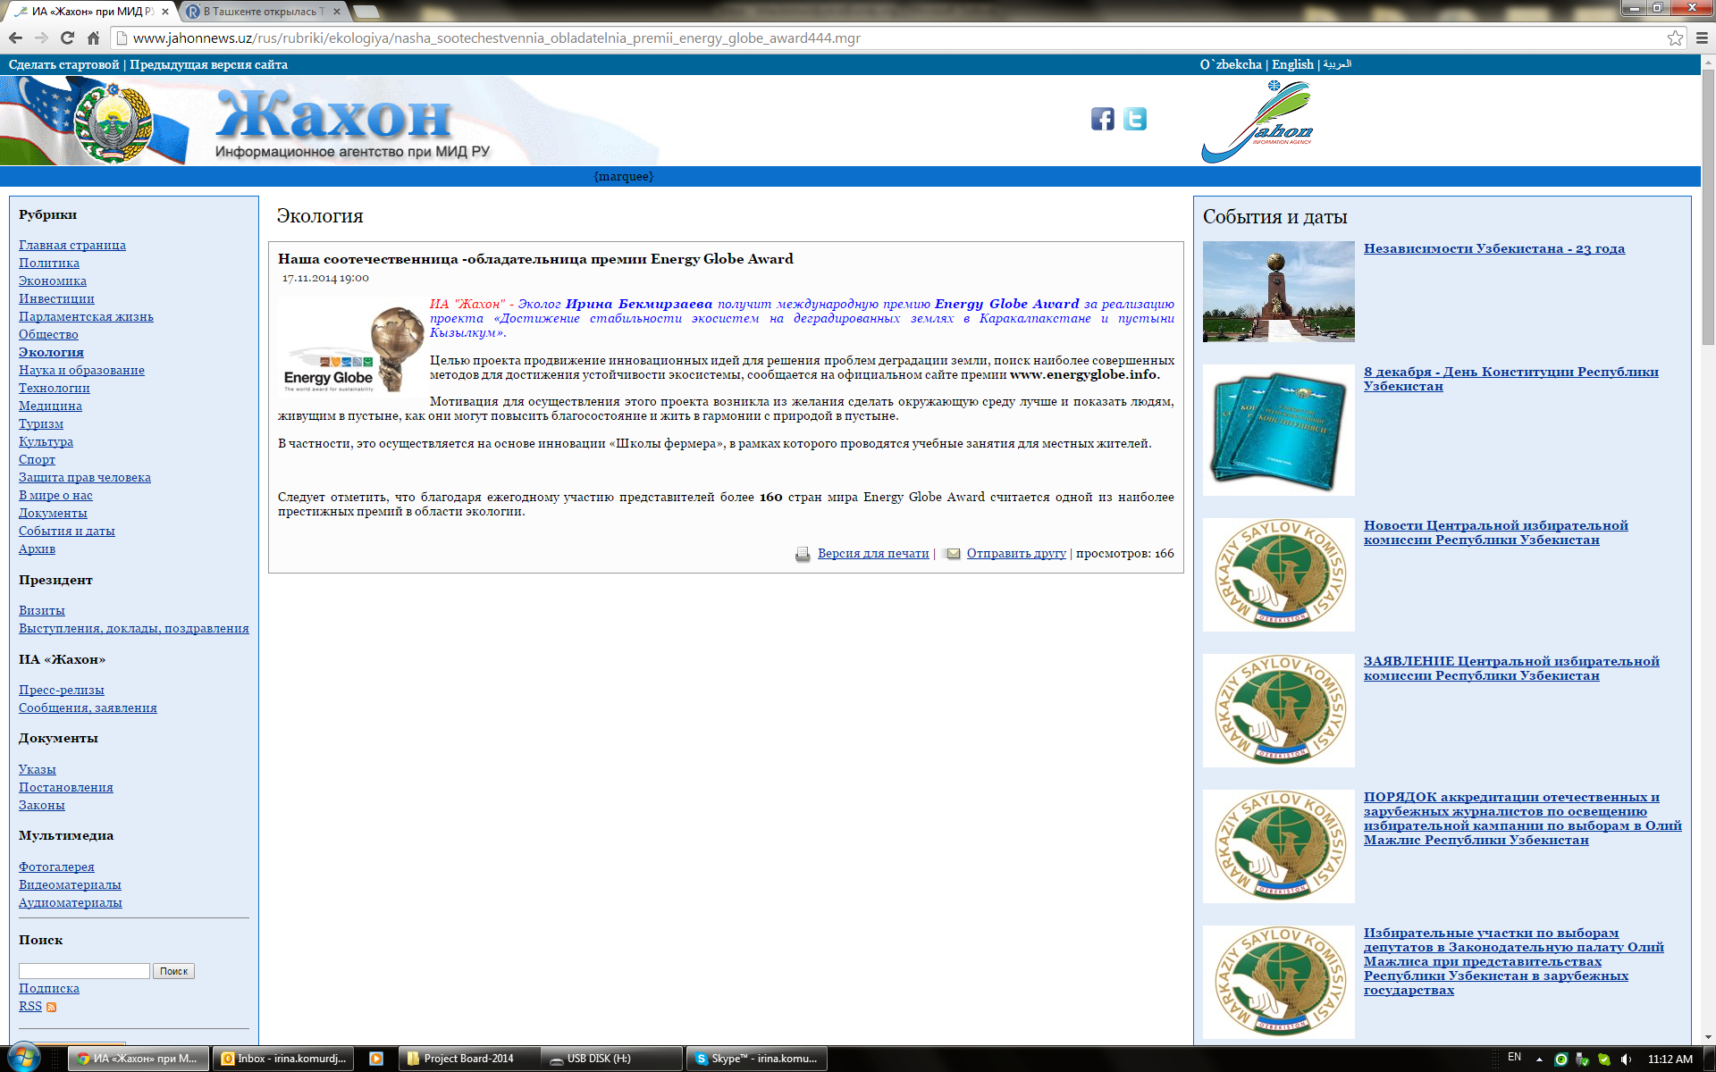

http://news.uzreport.uz/news_4_r_126339.html
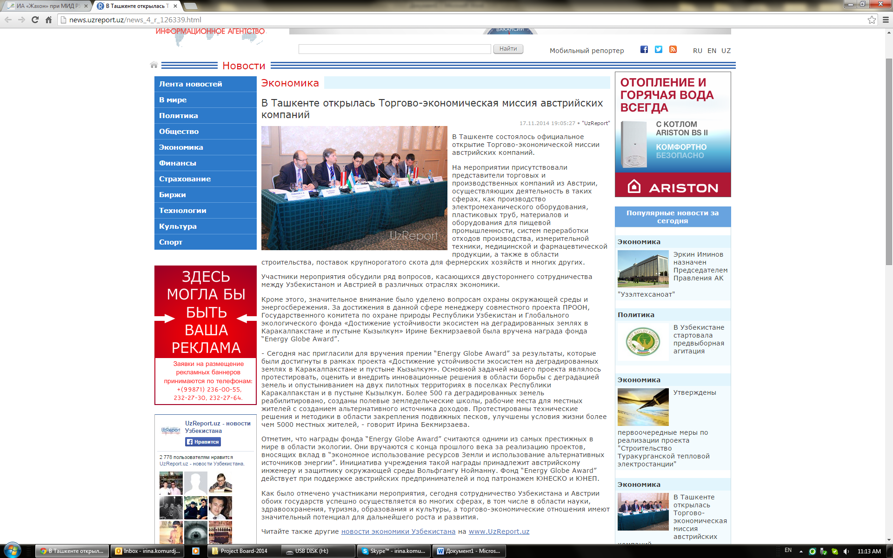

http://news.uzreport.uz/news_3_r_126277.html
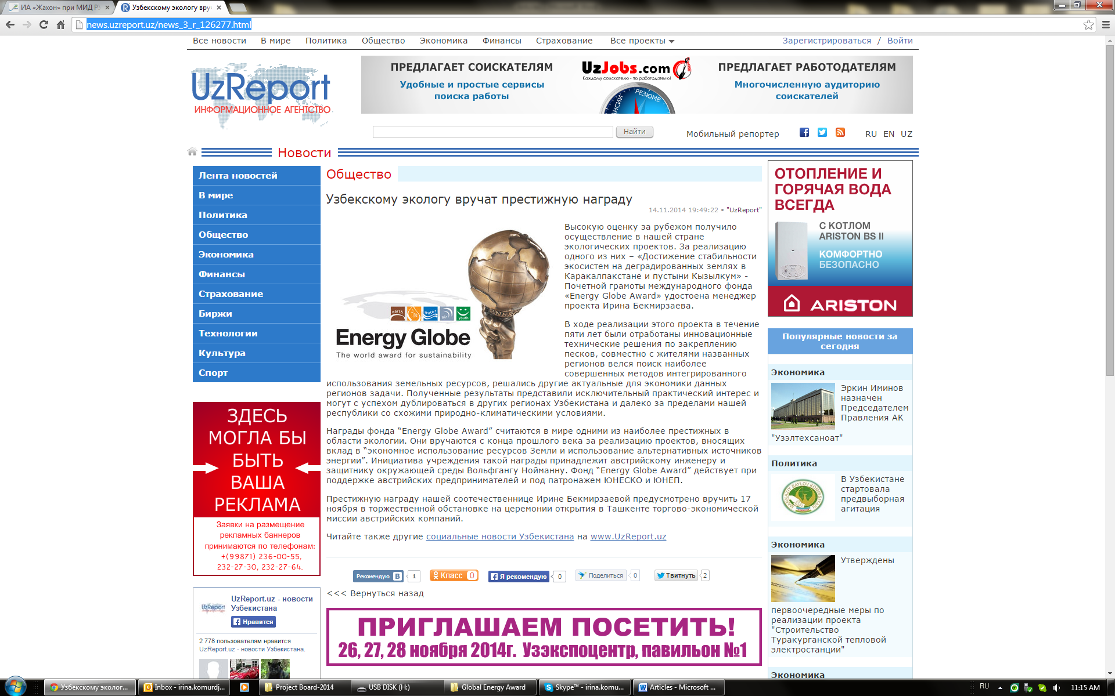

http://sreda.uz/index.php?newsid=1308
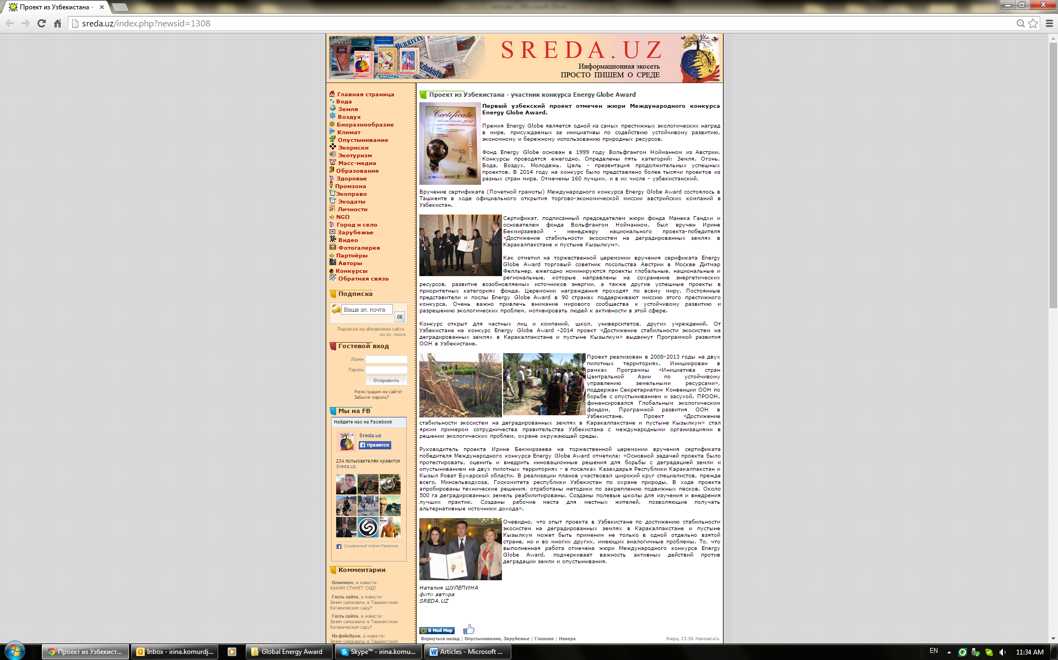

http://my.mail.ru/list/unep1972/
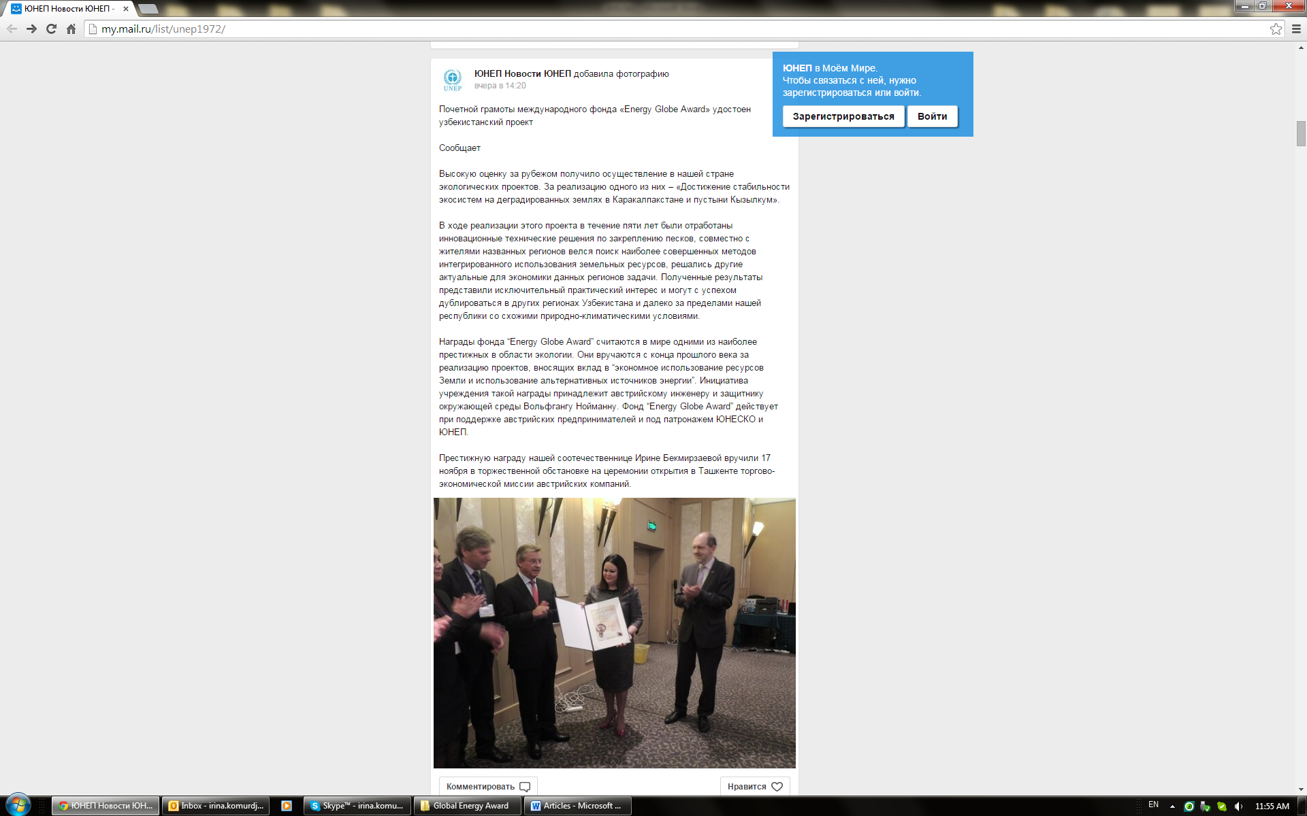
http://anhor.uz/news/ekolog-irina-bekmirzaeva-poluchit-mezhdunarodnuyu-premiyu-energy-globe-award
